Roll Number :  2020PECME185 | Branch :  Mechanical Engineering | Section : B  Batch : XVIII
Student Code Generated in Web Portal (Office Use)

ANNA UNIVERSITY
Office of Controller of Examinations
2114 – PANIMALAR ENGINEERING COLLEGE

(Student’s Profile to upload in Anna University web Portal - I Yr UG)
Mode of Admission* | DIRECT |  |  | LATERAL
Citizenship* | Indian
Mode of Education* | PART TIME |  |  | FULL TIME
Student Name*  (As in 12th Mark Sheet) | S.V. RAGUL
Gender* | Male
Date of Birth (DD-MM-YYYY)*  For Example : (12-12-2012) | 18-10-2020
Qualifying Examination*  (Tick) | HSC (ACADEMIC) |  | HSC (VOCATIONAL) |  | IF HSC (OTHER BOARD) – MENTION ______
Year of Passing (12th)* | 2020
NAD ID* (Refer attachment)
Mother Tongue* | Tamil
Father's Name* | R Sivakumar
Mother's Name | S. Vidyavathi
Community*  (OC/BC/BCM/MBC/SC/ST) | BC
AADHAR NUMBER* | 5132 6955 2680
MOBILE NUMBER* | 9791133406
Email id* | Ragul7villa@gmail.com
Differently abled person* | YES |  |  | NO
Permanent Address * | Door No | 72 |  | Street Name * |  | Rajaji 5th Street
Permanent Address * | Village/City Name | Thanikachalam Nagar E Block  Ponniammanmedu  Chennai |  | ZIP / PIN code* |  | 600110
Permanent Address * | Country* | India |  | STATE* |  | Tamil Nadu
Permanent Address * | District* | Chennai
DO NOT FOLD & SHEAR THE EDGES OF THIS SHEET
(P.T.O)

Pursuing Programme* | B.E/B.TECH
Branch of Study* | Mechanical
Aggregate marks in 12th  Physics (50) +  Chemistry (50)+ Maths (100) | PHYSICS MARK | 52 | Aggregate marks | PHYSICS MARK  (Out of 50) | 26 | Add & Mark out of 200  =  91
 | CHEMISTRY MARK | 48 | Aggregate marks | CHEMISTRY MARK  (Out of 50) | 24 | Add & Mark out of 200  =  91
 | MATHS MARK | 41 | Aggregate marks | MATHS MARK  (Out of 100) | 41 | Add & Mark out of 200  =  91
AFFIX RECENT PASSPORT SIZE PHOTO  (The same Photo will be printed in Your Degree Certificate)  Attach as separate JPEG File – less than 20 kb | 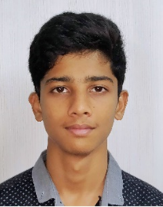  NAME OF THE STUDENT : S.V. RAGUL  Roll Number : 2020PECME185
Write a paragraph of 100 words in your own handwriting  (To identify student’s Handwriting)  Attach as separate JPEG File – less than 10 kb | 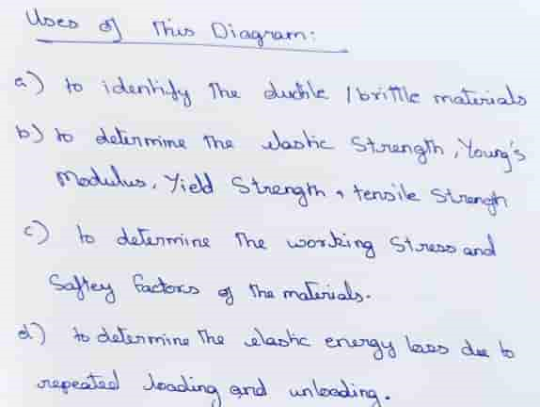
Signature of student  Attach as separate JPEG File – less than 10 kb | 